**Motivation**

This project aims to study the behavior of materials under cyclic loads by simulating is the oscillation of a 4 point-masses system with dampers. This study was inspired by the Millennium Bridge, which wobbled due to the rhythmic marching of footsteps, and it had to be closed.

**Technical Description of the System**

The system has 4 masses connected to each other and the wall by 5 springs and 5 dampers as shown below. The 4 masses are assumed to point masses with masses mi, connected by springs ki and ki+1 and unstretched length L0, and connected by dampers bi and bi+1.The first mass will be acted on by a cyclic force .

**add coordinate system

**Mathematical Model**

It is assumed that both the springs and dampers are massless and that the masses are point masses which do not experience any rotation during the movement. Also, the masses only move vertically in the y direction and that there is no movement in the x direction. Lastly, L0, free length of spring is taken as 0. The Lagrangian approach was used to derive the system’s equations of motion. This system has 4 degrees of freedom, with generalized coordinates y1, y2, y3 and y4 denoting the y position of the 4 masses. y0, ,y5, = 0 in the equations as they are fixed connection points of the spring and dampers mounted on the wall.

$\vec{r_{i}}=x_{i}\vec{e_{x}}+y_{i}\vec{e_{y}}$, $\dot{\vec{r_{i}}}={\dot{y}}_{i}\vec{e_{y}}$

$$T_{i}=\frac{1}{2}m_{i}\dot{\vec{r_{i}}}⋅\dot{\vec{r_{i}}}=\frac{1}{2}m_{i}{{\dot{y}}_{i}}^{2}$$

$$T=\frac{1}{2}m_{1}{\dot{y}}_{1}^{2}+\frac{1}{2}m_{2}{\dot{y}}_{2}^{2}+\frac{1}{2}m_{3}{\dot{y}}_{3}^{2}+\frac{1}{2}m_{4}{\dot{y}}_{4}^{2}$$

$$Total kinetic energy of masses:$$

$$T_{total}=\frac{1}{2}\sum_{i=1}^{n}{m_{i}{{\dot{y}}_{i}}^{2}}$$

$$V_{gravity}=m_{1}gy_{1}+m_{2}gy_{2}+m_{3}gy_{3}+m_{4}gy_{4}$$

$$Total gravitational potential energy: \\ V_{gravity, total}=g\sum_{i=1}^{n}{m_{i}y_{i}}$$

The spring extensions are given as follows:

$\text{Δ} y_{i}=\sqrt{{\left(y_{i-1}-y_{i}\right)}^{2}+d^{2}}$, d is the horizontal separation between the masses

$$Total spring potential energy: \\ V_{spring, total}= \frac{1}{2}\sum_{i=1}^{5}{k_{i}∆y_{n}^{2}}$$

$$V=V_{spring,total}+V_{gravity,total}$$

$$L=T-V$$

$$\frac{∂L}{∂y_{i}}=-k_{i}\left(y_{i}-y_{i-1}\right)-k_{i+1}\left(y_{i}-y_{i+1}\right)$$

$$\frac{d}{dt} \left(\frac{∂L}{∂{\dot{y}}_{i}}\right)=m_{i}\ddot{y_{i}}$$

$$y_{i}: \frac{ⅆ}{ⅆt}\left(\frac{∂L}{∂{\dot{y}}_{i}}\right)-\frac{∂L}{∂y_{i}}=Q_{y_{i}}^{nc}$$

$$Work done by damping force,$$

$$W_{bi}=-b_{i}\left({\dot{y}}_{i}-{\dot{y}}_{i-1}\right)\left(y_{i}-y_{i-1}\right)$$

$$W_{b,total}=\sum_{i=1}^{5}{W_{bi}}$$

$$\frac{∂W_{b, total}}{∂y_{i}}=-b_{i}\left({\dot{y}}_{i}-{\dot{y}}_{i-1}\right)-b_{i+1}\left({\dot{y}}_{i+1}-{\dot{y}}_{i}\right)$$

Non-conservative forces for respective masses can be represented as:

$$Q_{y_{i}}^{nc}= \frac{∂W_{b, total}}{∂y_{i}}+F_{i}\left(t\right)$$

Hence, the general equation for the respective masses can be presented in the form



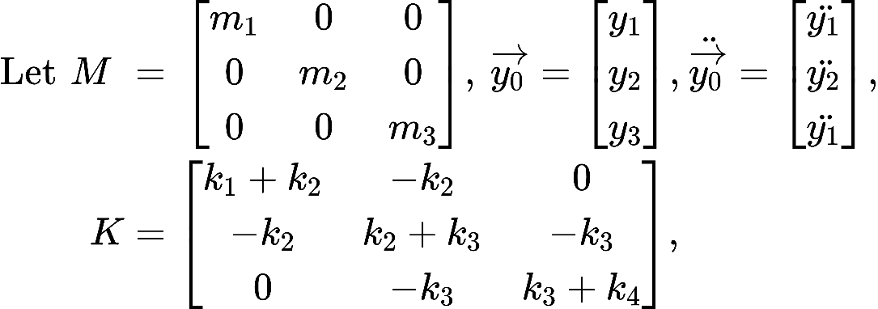

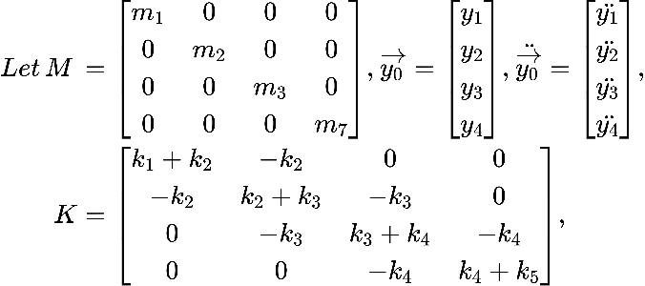

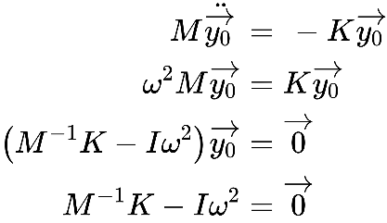

{"id":"3rlt9m3oj9g1636974545404","code":"$\\text{For}\\,\\,\\text{3}\\,\\,\\text{masses,}$","font":{"size":5.4,"family":"Times New Roman","color":"#000000"},"type":"$","ts":1637065154722,"cs":"ae2dc531650b4c4c61fc7da56","size":{"width":48.6,"height":7.2}}

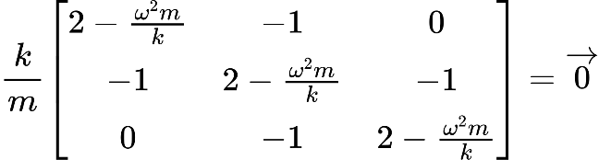

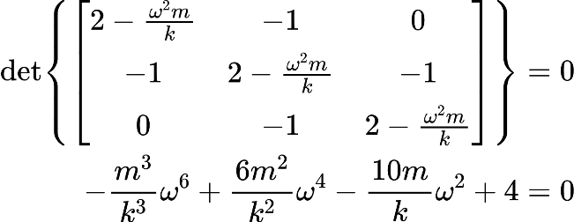

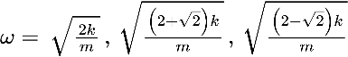

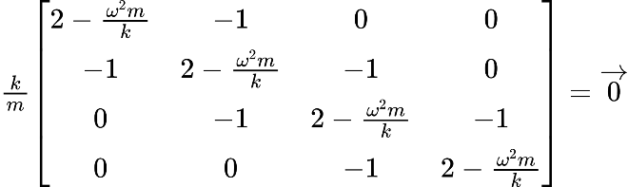

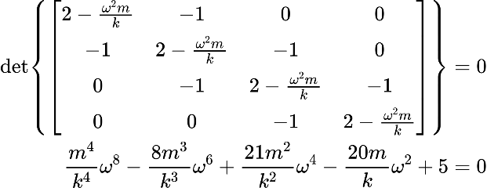 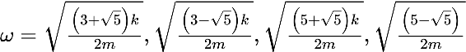

:

{"id":"3rlt9m3oj9g1636974545404","code":"$\\text{For}\\,\\,\\text{3}\\,\\,\\text{masses,}$","font":{"size":5.4,"family":"Times New Roman","color":"#000000"},"type":"$","ts":1637065154722,"cs":"ae2dc531650b4c4c61fc7da56","size":{"width":48.6,"height":7.2}}

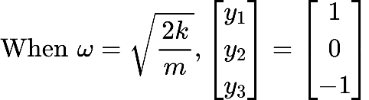

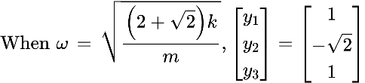

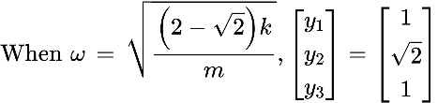

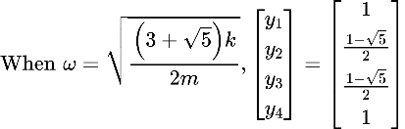 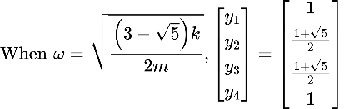

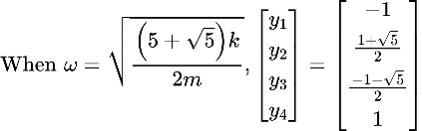 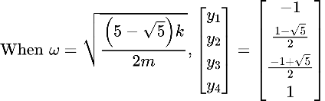

**Numerical Analysis**

The system experienced resonance at the calculated four distinct frequencies as expected (see figure 1) when the damping constants were low (0.01). As the damping constant increased for all the dampers, the peaks began to smoothen out and the number of resonant frequencies became less clear (see figure 2a).

Next, selected dampers were given a higher constant to analyse the system behaviour, starting with one, two and three dampers at various possible positions. Comparisons were made against the case when all dampers had a constant of 0.1. Generally, having more larger dampers resulted in reduced resonance. The following section will point out the exceptions.

For the cases with one larger damper (see figure 2b), when the middle damper (b3) was larger, it had minimal impact on the system’s resonance.

For the cases with two larger dampers (see figure 2c), there were two arrangements that increased the system resonance significantly. Firstly, having the 2nd and 4th damper as larger dampers nearly doubled the first resonance amplitude. Secondly, having the 3rd and 4th damper as larger dampers increased resonance by 490 times. The system had the most reduction in resonance when the larger dampers were at the ends (1st and 5th).

For the cases with three larger dampers (see figure 2d), having the middle three dampers as larger dampers increased the system resonance greatly.

As a further comparison, figure 2e shows that having two larger dampers at the ends had a greater reduction in resonance than having three larger dampers in the middle.

**Summary**

**Appendix**

Figure 1

Graph of maximum amplitude against frequencies with all damping constants at 0.01.

Figure 2a

Graph of maximum amplitude against frequencies for various damping constants from 0.01 – 10.

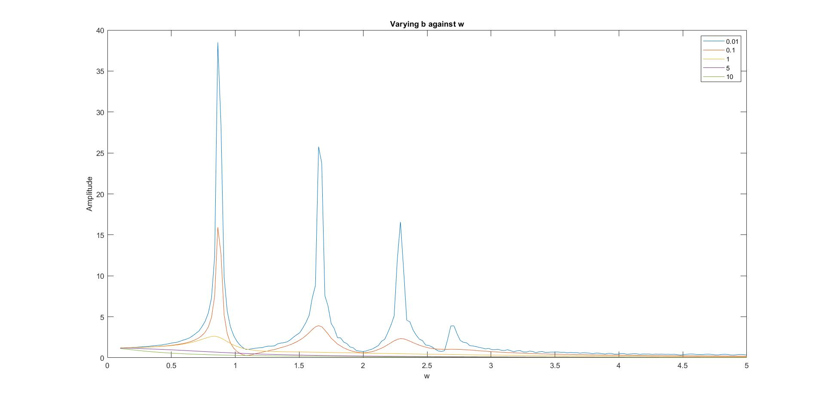

Figure 2b

Graph of maximum amplitude against frequencies for various combinations of having 1 larger damper.

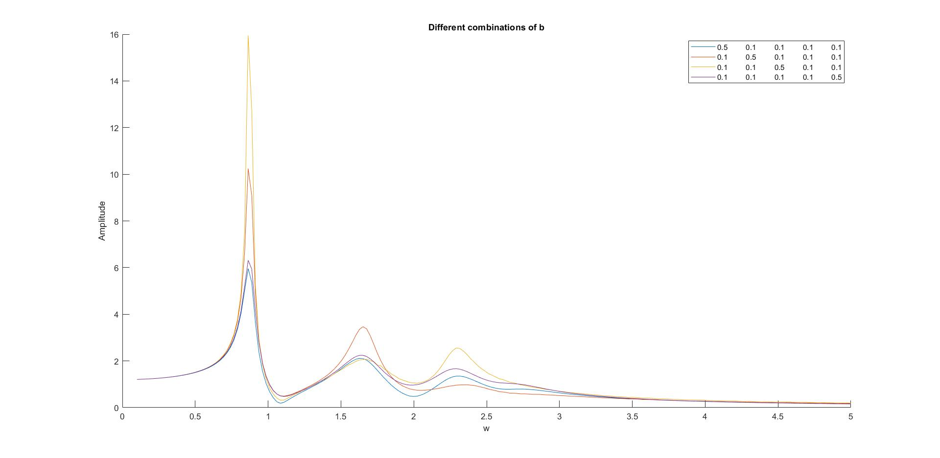

Figure 2c

Graph of maximum amplitude against frequencies for various combinations of having 2 larger dampers.

Case with [0.1 0.1 0.5 0.5 0.1] has been omitted due to its large first resonance amplitude of 7848.

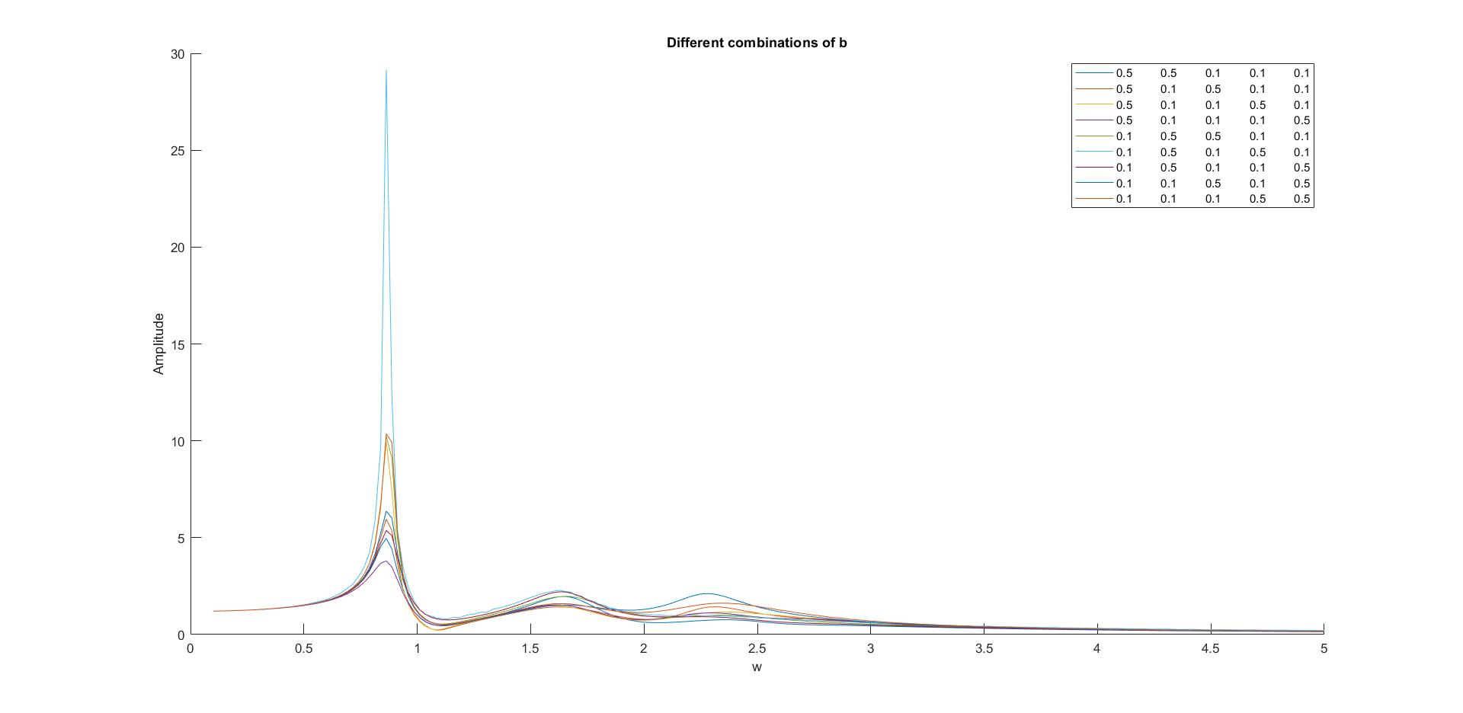

Figure 2d

Graph of maximum amplitude against frequencies for various combinations of having 3 larger dampers.

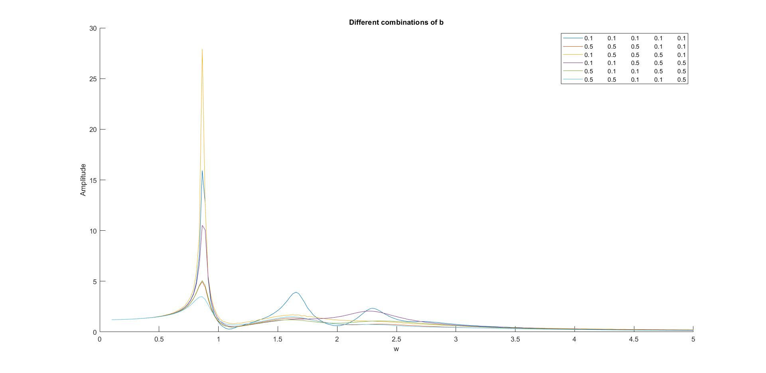

Figure 2e

Graph of maximum amplitude against frequencies for 3 large middle dampers and 2 larger end dampers.

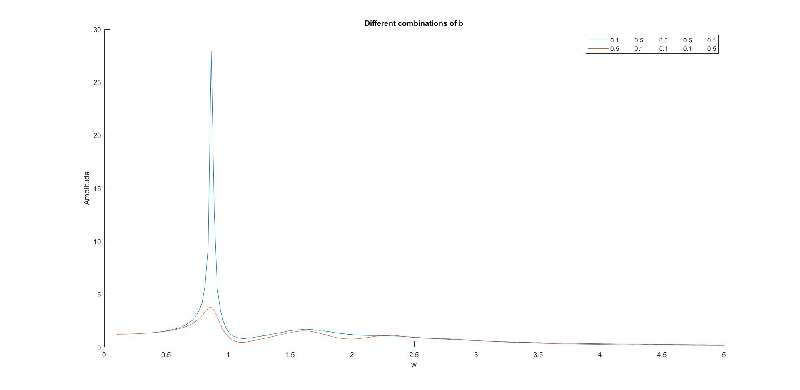

Figure 3

Graph of maximum amplitude against frequencies for different combinations of forcing functions with different phases.

